NAME: |  | 23.11.2015
SURNAME:
CLASS & NUMBER: |  |  |  |  |  |  |  | MARK:
ANATOLIAN HIGH SCHOOL
2015-2016 EDUCATIONAL YEAR – 12th GRADE (LEVEL A 2 3)
THE FIRST TERM / THE FIRST EXAM
- VOCABULARY PART (32 points)
- Weather conditions (Write the name of the weather according to the pictures) (2X5=10 points)
W___________ |  |  |  | S_____________ |  |  |  |  | F______________ |  |  |  | C___________ |  |  |  |  |  |  |  |  | S___________
- Write the given words below under the correct picture or in the blanks of the sentences (11X2=22)
changing room, found and lost, early person, elavator/lift, individual, kids, lie, off day, sleeping bag, torch, vacation

 |  |  | 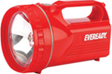
- __________ |  |  | - __________ |  |  | - __________ |  |  |  |  | - __________ |  |  |  |  |  | - __________ |  |  |  |  |  | - __________
- Susan goes to bed before 10 o’clock, because she is a/an ______________ on weekdays.
- I work on Monday, Tuesday, Wednesday, Thursday, Friday and Saturday. I don’t work on Sunday. Sunday is my ___________.
- On Sundays, I usually ____________ on the sofa and have rest for a while.
- Customer: Can I try This T- shirt, please?
Shop assistant: Yes, you can. Our _______________ is over there. You can wear it there.
- Surfing on the net is a/an ___________ activity. It is not a pair or group activity.
- READING PART (30 points)
- Read the story and answer its questions (2X5=10 points)
HANNA AND HER BIKE
Hanna is a post woman. She works at the post office.
It's five o'clock in the afternoon. Hanna is on her way home. She is riding her bike.
Hanna's friend Sara is on her way home, too. Hanna is near Sara now. Hanna is looking at Sara, and she is talking to her. Hanna is not looking at the road.
Hanna is falling. Hanna is holding her leg. It hurts. The ambulance is here. The ambulance is taking Hanna to the hospital. Her leg is broken. Sara is with Hanna in the ambulance. She is holding Hanna's hand and saying: "Don't worry, you will be fine".
- Where does Hanna work? |  |  |  |  |  |  |  |  |  |  |  | _________________________________________
- Where is Hanna going? |  |  |  |  |  |  |  |  |  |  |  | _________________________________________
- Who is Hanna's friend? |  |  |  |  |  |  |  |  |  |  |  | _________________________________________
- What is Sara saying to Hanna when she is holding her hand? |  |  |  |  |  |  |  |  |  |  |  | _________________________________________
- Why isn't Hanna looking at the road? |  |  |  |  |  |  |  |  |  |  |  | _________________________________________
- Complete the dialogue with the given sentences (2X5=10 points)
- When would you like to go? |  | - How much is it? |  | - And for how many people?
- How many days would you like to stay? |  |  | - How can I help you?
Travel Agent: | The Sunset Travelling Agency. ___________________________ (1)
Mr. Brown : | Well, I’d like to book a holiday in Venice, please.
Travel Agent: | Certainly. ____________________________ (2)
Mr. Brown : | On 1st August.
Travel Agent: | _______________________ (3)
Mr. Brown: | For fifteen days. I want to return on 15th August.
Travel Agent: | OK. ______________________________ (4)
Mr Brown: | Oh, just one. For me. _________________________ (5)
Travel Agent: | 15 days in Venice for £699. It includes return ticket, plus hotel with breakfast and dinner.
Mr. Brown: | Great. That’s fine.

- Write the name of the people on the picture and complete the 10th sentence (1X10=10 points)
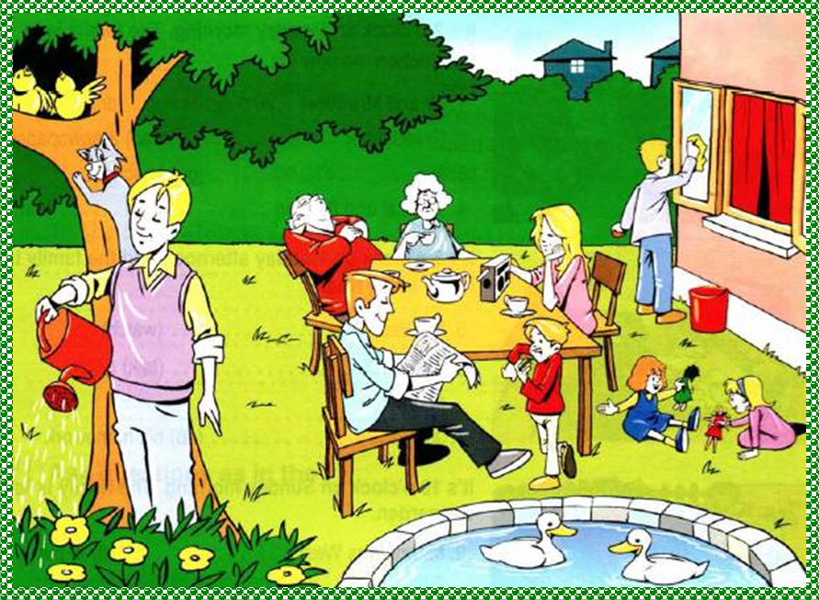 |  |  |  |  |  |  |  |  |  |  |  |  |  |  |  |  |  |  | - I’m Carol. I’m playing with a green doll and sitting near my mother.  - Harry is my father. He is reading the newspaper.  - Carla is my mother. She is listening to the radio.  - Edith is my grandmother. She is drinking tea.  - William is my grandfather. He is sleeping.  - Peter is my brother. He is cleaning the windows.  - Sally is my sister. She is playing with me. There is a bandana on her hair.  - Paul is my cousin. He is eating a sandwich and standing near the table.  - Tom is my uncle. He is watering the plants.  - __________ is climbing the tree and looking my uncle, Tom.
- GRAMMAR PART (38 points)
- Choose the correct one. Simple Present Tense or Present Continuous Tense (6X2=12 points)
- They are singing/sing an English song at the moment.
- Are they writing/Do they write letters to their friends every week?
- Look! That dog is eating/eats your sandwich!
- He is trying/tries to make a bird-house now.
- My parents aren’t working/don’t work late on Fridays.
- Why are you coming/do you come late to school so often?
- Fill in the blanks with “Possessive adjectives” (my, your, our, their, her, his, its) (2X5=10 points)
- I love my mother. _________________ name is Mary.
- John has a brother. __________________ brother is 25 years old.
- I want to phone Sarah and David. Do you know __________________ telephone numbers?
- Do you live with ______________ parents?
- I'm a student in Hartford Secondary. _______________ name is Jason.
- Fill in the blanks with “can” or cannot” (2X5=10 points)
 | sing | dance | play the piano | do the ironing | ride a horse
JON | √ | √ | χ | χ | χ
DAN | χ | √ | χ | √ | χ

- Jon ____________ but Dan ___________ sing. |  |  |  |  |  |  |  |  |  |  | - ___________Jon and Dan dance? Yes, they ________.
- ________ John and Dan play the piano? No, they _____. |  |  |  |  |  |  |  |  |  |  | - Jon or Dan ________________ ride a horse.
- Dan ___________ do the ironing, but Jon _____________ do the ironing.
- Choose the correct option – (Time and frequency Adverbs) (1X6=6 points)
- The sun is ________________ hot. |  |  |  |  |  |  |  |  |  |  | - Do you ever fail tests? No. I ___________ fail tests.
- always | - often |  |  |  | - usually |  |  |  |  | - never | - sometimes |  |  |  |  | - usually |  |  |  | - never |  |  |  | - ever
- She read the newspaper _____________. |  |  |  |  |  |  |  |  |  |  | - You are eating an ice cream _________.
- now | - everyday |  |  |  | - always |  |  |  |  | - stilll | - now |  |  |  | - everyday |  |  |  |  |  | - still |  |  |  | - often
- I live in İstanbul but _______ I am living in Antalya. |  |  |  |  |  |  |  |  |  |  | - Almost of all Rosemary’s teeth are good because she _______ brushes them.
- twice a week | - usually |  |  |  | - at the moment |  |  |  |  | - never | - usually |  |  | - still |  |  |  |  |  | - never |  |  |  | - rarely
Time is 40 minutes |  |  |  |  |  |  |  |  |  |  |  |  |  |  |  |  |  | GOOD - LUCK
The Teacher of The Lesson
Serkan EKİN

