AKKUŞ ANADOLU LİSESİ
İNGİLİZCE DERSİ ____ DÖNEM ____ YAZILI SORULARI

1) | MARTHA'NIN SIMON'A YAZDIĞI MEKTUBU HATIRLAYALIM VE SORULARA CEVAP VERELİM  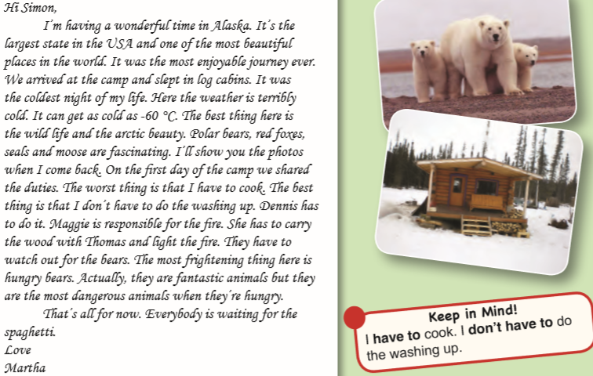  1.The worst thing in the camp is _____________________________________  2.The best thng i the camp is __________________________________  3.The largest state in USA is __________________________________  4.The most frightening thing is ________________________________  5. The most dangerous animal in the camp is ________________________________________

2) | ÜLKELERİN SOL TARAFINA BAŞKENTLERİN ADINI YAZINIZ.  _____________1) GREECE a)MOSCOW  _____________2) EGYPT b) ATHENS  _____________3) AUSTRALIA c)WASHINGTON D.C.  _____________4) CANADA d)CAIRO  _____________5) NEW ZELLAND e)CANBERRA  _____________6) RUSSIA f)ANKARA  _____________7) U.S.A. g)OTTOWA  _____________8) TURKEY h)PARIS  _____________9) FRANCE j)WELLINGTON  _____________10) SPAIN k)MADRID

3) | 11 MART 2011 GÜNÜ YEREL SAAT İLE 02:46'DA JAPONYADA MEYDANA GELEN TSUNAMİ FELAKETİ İLE İLGİLİ PARÇAYI OKUYUP SORULARI DÜZGÜN OKUNAKLI BİR YAZIYLA CEVAPLAYINIZ  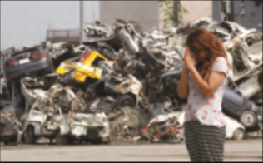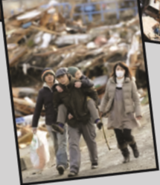  The most powerful earthquake hit Japan on Friday March 11, 2011 at 2.46 p.m local time. The earthquake was 8.9 magnitude. A huge tsunami followed the earthquake. The waves reached six miles on Japan’s northeast coast. The wall of water swept away cars, ships and buildings. The earthquake and tsunami caused extensive damage and there were thousands of deaths and hundreds of missing people. In Tokyo people screamed and grabbed each other’s hands when the quake hit. The shock was so powerful that even the people in Beijing felt it.  1.Where did the earthquake occur? __________________________________________________________  2.What was the magnitude of the 2011 Tohoku earthquake? __________________________________________________________  3.What happened after the earthquake? __________________________________________________________  4.Why were there thousands of deaths? ___________________________________________________________  5.Did the people in Beijing feel the earthquake?  ___________________________________________________________

4) | AŞAĞIDA VERİLMİŞ OLAN CÜMLELERİN İLGİLİ RESİMLERİN YANINA DÜZGÜN OKUNAKLI VE GÜZEL BİR YAZIYLA YAZINIZ  **I work as a columnist at a newspaper, but I’m going to do a degree in Art. I’m crazy about painting. I’m planning to have my own exhibition. I hope my readers will love my paintings.  **As a stock broker I’m planning to retire early before I’m 45. Then I’d like to run my own restaurant. I’m going to make wonderful dishes. I’m sure my restaurant will be the number one in the city.  **My wife and I work as archeology professors at a university. We’re going to retire next month. We’re planning to spend about a year travelling and we’re really looking forward to it. I’m sure we’ll have a great time.    ______________________________________________________________________________________________________________________________________________________________________________________________________________________________________________________________________________________________________________________________________________________________________________________________________________________________________________________________________________________________________________________________________________________________________    ______________________________________________________________________________________________________________________________________________________________________________________________________________________________________________________________________________________________________________________________________________________________________________________________________________________________________________________________________________________________________________________________________________________________________    ______________________________________________________________________________________________________________________________________________________________________________________________________________________________________________________________________________________________________________________________________________________________________________________________________________________________________________________________________________________________________________________________________________________________________

5) | TEST SORULARINDA DOĞRU CEVABI YUVARLAK İÇİNE ALINIZ  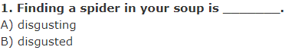  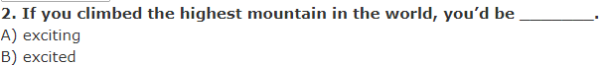  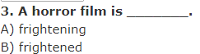  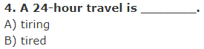  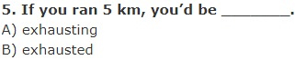

6) | ULU ÖNDER MUSTAFA KEMAL ATATÜRK İLE İLGİLİ SORULARI CEVAPLAYINIZ  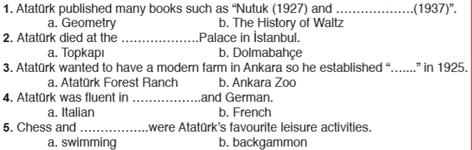

7) | AŞAĞIDA COĞRAFİ YERLERİN İSİMLERİ VERİLMİŞTİR. GÜZEL TÜRKİYEMİZDEN BU YERLERE ÖRNEKLER YAZINIZ.  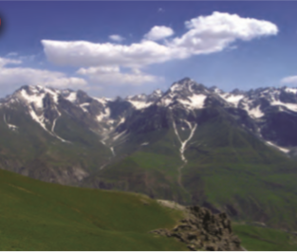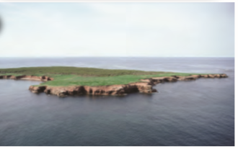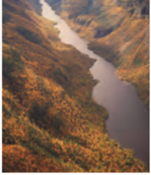  1. Lake: _________________________  2. Mountain: ________________________  3. Island: _____________________  4. River: ___________________________  5. Falls: _________________________

