OKULUNUZUN ADI

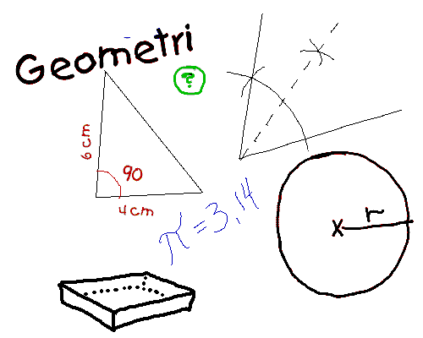

|  |  |
| --- | --- |
| **ADI** | **:** |
| **SOYADI** | **:** |
| **SINIF** | **:** |
| **NO** | **:** |

j0134667